**Student’s Project**

**MOROCCO**



**Children’s Education in Case Divorce in Morocco**

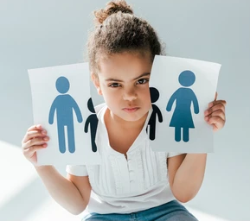

**The researcher : Oumaima Lakhlif**

Supervised by : Prof. Mohamed Fettah

School: Moulay Ismail High School

**Outline**

1. **Part One (Theory) ...........................................................**
2. **Introduction.**
3. Global perspectives on divorce and children’s education.
4. Overview of the impact of divorce on children's education in Morocco
5. **Problems and challenges.**
6. Overview of divorce rates in Morocco and its social implications.
7. Examining the impact of divorce on children’s performance and access to education, their emotional well-being, and their personal traits.
8. **Recommendations.**
9. Practical measures to mitigate the negative effects of divorce on children’s education.
10. Models for encouraging co-parenting and community support networks in case divorce.
11. **Part Two (Practice) ........................................................**

* **Doing surveys and interviews with divorced parents, children, teachers, and legal professionals.**
* **Making a video to share my own views about this topic.**

**Abstract**



**Divorce is widely recognized as a life event that profoundly affects children particularly their education. In Morocco, the rising divorce rates over the past few years caused too much controversy about the challenges faced by children from divorced families. In fact, this growing concern calls for an in-depth understanding of the issue and the development of strategies to mitigate the negative effects of divorce on children’s education.**

**This research explores the various ways divorce disrupts children’s life. From emotional distress that impedes their concentration and motivation at school to family instability that limits their access to resources. Moreover, the research identifies key areas where intervention is needed in order to help children in case divorce within schools.**

**In response to these challenges, the research also offers actionable recommendations to ensure stability for children during and after divorce. These recommendations emphasize the need for school-based support systems.**

**Ultimately, the findings of this research highlight the importance of a united effort to create an environment where children affected by divorce can thrive both academically and emotionally.**

"The foundation of a society is built upon the stability of its families, for in them lies the nurturing of the next generation."

Ibn Khaldun